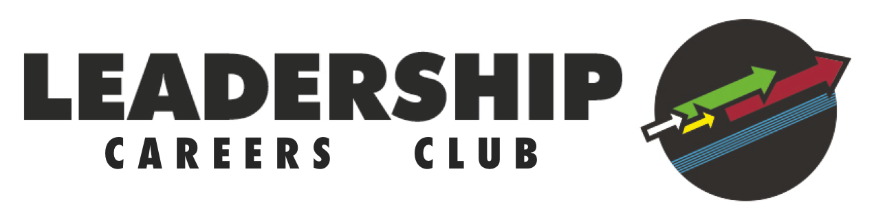
Safeguarding and Protecting Young People Guidelines

Given their age and established relationships with LTSB staff, it is extremely unlikely that a young person will make a disclosure of a sensitive nature to a volunteer. However, these guidelines still represent best practice for engaging with our young people, and if any issues arise please contact LTSB Deputy CEO & Ops Director pete.ward@leadershipthroughsport.org

Good practice

Mentors:

- should always be publicly open when working with young people
- should avoid any unobserved situations and encourage open communication
- must treat all young people equally and with respect and dignity
- must keep an appropriate distance between yourself and the young person; intimate relationships are not allowed
- must avoid unnecessary physical contact with young people
- should be a good role model
- should give enthusiastic and constructive feedback rather than negative criticism
- must recognise the developmental needs and capacity of the young person and not risk their wellbeing to gain other successes.

Poor practice

Mentors:

- must not unnecessarily spend time alone with a young person
- must not reduce a young person to tears as a form of control
- should not do things of a personal nature that the young person can do for themselves
- must not engage in rough, highly physical or sexual activity
- must not make sexually suggestive comments to a young person
- must not engage in improper touching of any form
- must not allow young people to openly use unsuitable language, esp. racist, sexist, homophobic
- must not allow allegations made by a young person to go unchallenged, unrecorded or not acted upon. Please refer to Pete Ward immediately.

